

In proposing to raise prices commiserate with the product Big Mountain brings, we analyzed many different features to categorize our features and maximize our possible value to match market-demand price.

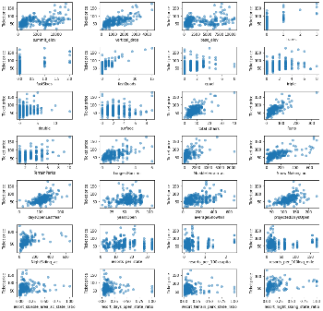The scatterplots to the left show indications of potential trends between the features a resort offers and its ticket price. Many of these trends looked promising, so these features needed further analysis through a machine-learning model. The goal is to emulate the features of the resorts with higher costing tickets while minimizing features that seem to make little to no difference in order to minimize operating costs.

Our predictive model was given a portion of the data to train on while some of the data was reserved to test the accuracy of the predictive model.

Our predictive model was designed to determine the most important features that led to higher ticket prices. Our model determined that the four most important features were fastQuads, the number of Runs, Snow Making, and the height of the Vertical Drop. As the chart on the right illustrates, most ski resorts do not have any fast quads, but Big Mountain has 3. According to our model, this is an ideal amount of fast quads to have in the resort.

We came up with several scenarios that we simulated in order to maximize ticket price. The first of these scenarios would be to close the lesser used runs. This is an effective cost-saving measure that should not detrimentally affect value compared to ticket price. Our model predicted that closing a single run would not affect our ticket price, but it would not affect our general costs either. The model suggested that we close a total of five runs.

The next scenario predicts our change in ticket price were we to increase the vertical drop by 150 feet. Our model indicated that this would increase our potential ticket price by $8.61 leading to an increase to our margin of over $15 million. Were we to do this and increase our snow-making capabilities by two acres, the value would not rise in any significant way.